**Cryptography and Network Security Lab (6CS451)**

**Assignment No 3**

**Name : Vijay Sambhaji Mali**

**PRN : 22520008**

1. Implementation of Euclidean and Extended Euclidean Algorithm

**Code :**

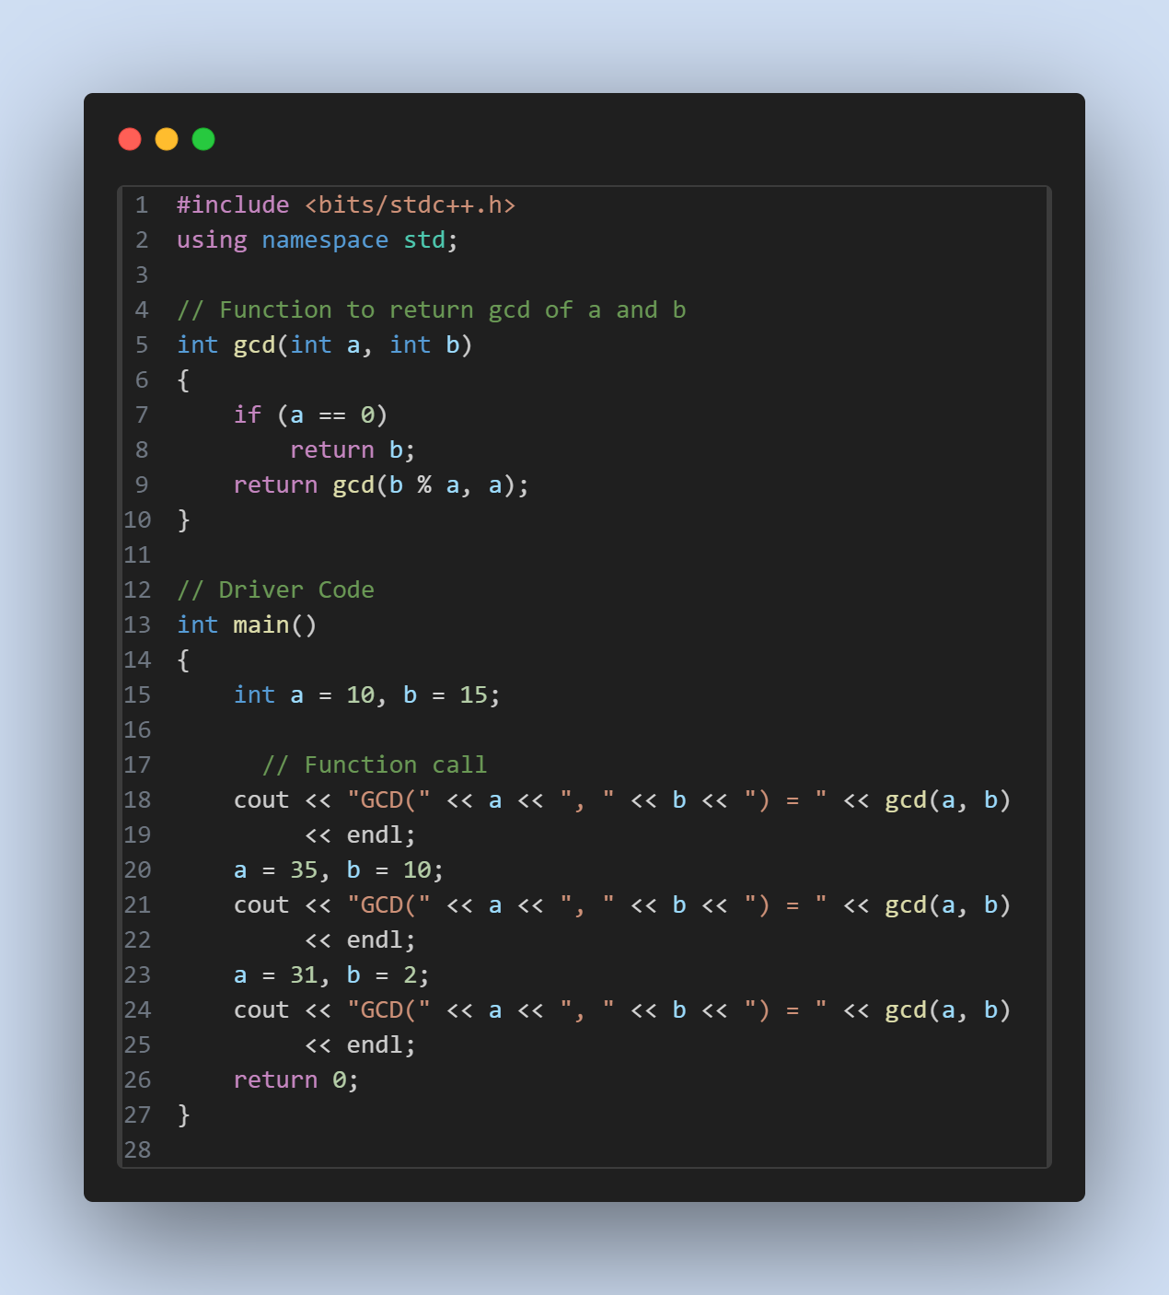

**Output :**

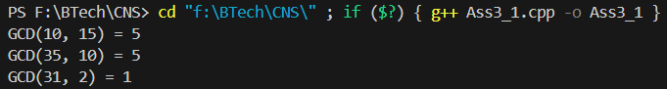

**Code :**

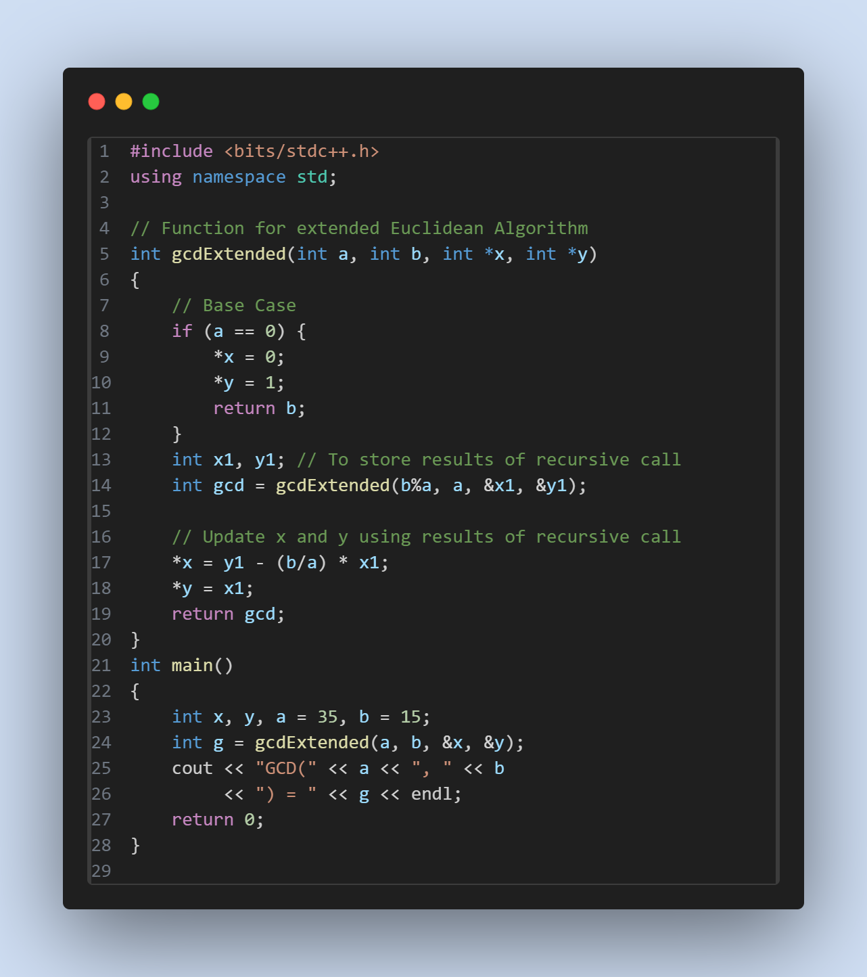

**Output :**

